Alexander Shah
Project 1 – Morse Code LED
2024-02-04
EN.605.715.81.SP24
Table of Contents
Requirements 1
Design 1
Implementation 1
Demo 6
References 7

NOTE to the Grader: My Arduino kit arrives the day after the deadline for this project, so the demonstration uses the integrated LEDs on an Arduino Micro to flash the message, but the code and functionality is the same.

Requirements
This projects uses an Arduino Micro, an LED, a resistor, and wiring, to create a blinking morse code beacon using a connected device for text input. The program uses a loop to capture input until a quit command is given, either control + Z or the string “QQ”. The project was written in Arduino IDE in a C like language and deployed on a knock off Arduino Micro. These designs requirements are from the Project 1 prompt.

Design
The Arduino Micro, LED, resistor, and wiring are assembled simply on a breadboard, as seen in Figure 1 below. The Arduino pin defined in the code uses pin 9 at the corner of the board, compared to the image below which shows another pin. The long arm of the LED should be connected to the output pin, and the resistor should be connected between the short leg and ground, shown in barely visible white below the board in the image below. The demonstrated implementation does not contain the breadboarding, but instead uses the integrated LEDs of an arduino micro to flash the message. The code and functionality remains the same.
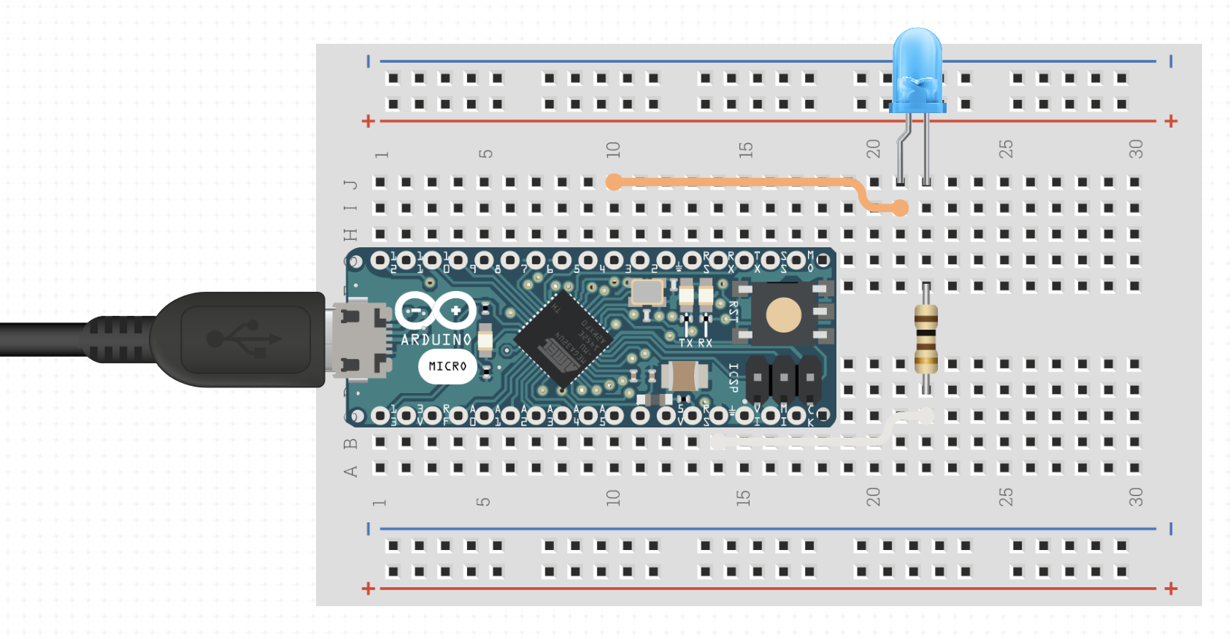

(Figure 1) Assembled project layout

Implementation
The code for the Project, written in Arduino IDE, can be compiled and run as a single file, the contents for the morse.ino file are:

/* Project 1 - Arduino Morse Code
Alex Shah
1/28/24
*/

//using a knock off arduino micro, assign pin 9 for led output, or use rx/tx led to blink
int iLEDPIN = 9;
int iRXLED = 17;
int iTXLED = 30;

//1 unit for dot
//3 units for dash
//1 unit between dot/dash in same letter
//3 units space between letters
//7 units between words
int iUnit = 300;

//use control + Z to terminate loop, ascii character is '\x1A'
bool fInterrupt = false;

void setup() {
pinMode(iLEDPIN, OUTPUT);
pinMode(iRXLED, OUTPUT);
pinMode(iTXLED, OUTPUT);

Serial.begin(9600);
while (!Serial) {
//wait for serial connection
;
}
Serial.println("Enter some text (A-Z,a-z), then press enter and watch the led flash your message! Use control + z or 'QQ' to quit.");
}

void loop() {
while (!fInterrupt) {
if (Serial.available()) {
// convert input to morse code until interrupted with control + Z, or QQ because control + z not sent through Arduino IDE
String input = Serial.readStringUntil('\n');
input.trim();
if (input == '\x1A' || input.equalsIgnoreCase("QQ")) {
fInterrupt = true;
} else {
//sleep to prevent first input getting eaten
stop_leds();
delay(2000);

show_morse(input);
stop_leds();
}
}
// sleep on loop break
delay(1000);
}
Serial.println("Program exiting...");
stop_leds();
delay(1000);
exit(0);
}

void show_morse(String input) {
for (int i = 0; i < input.length(); i++) {
char character = toUpperCase(input[i]);
switch (character) {
case ' ':
word_space();
break;
case 'A':
dot();
dash();
letter_space();
break;
case 'B':
dash();
dot();
dot();
dot();
letter_space();
break;
case 'C':
dash();
dot();
dash();
dot();
letter_space();
break;
case 'D':
dash();
dot();
dot();
letter_space();
break;
case 'E':
dot();
letter_space();
break;
case 'F':
dot();
dot();
dash();
dot();
letter_space();
break;
case 'G':
dash();
dash();
dot();
letter_space();
break;
case 'H':
dot();
dot();
dot();
dot();
letter_space();
break;
case 'I':
dot();
dot();
letter_space();
break;
case 'J':
dot();
dash();
dash();
dash();
letter_space();
break;
case 'K':
dash();
dot();
dash();
letter_space();
break;
case 'L':
dot();
dash();
dot();
dot();
letter_space();
break;
case 'M':
dash();
dash();
letter_space();
break;
case 'N':
dash();
dot();
letter_space();
break;
case 'O':
dash();
dash();
dash();
letter_space();
break;
case 'P':
dot();
dash();
dash();
dot();
letter_space();
break;
case 'Q':
dash();
dash();
dot();
dash();
letter_space();
break;
case 'R':
dot();
dash();
dot();
letter_space();
break;
case 'S':
dot();
dot();
dot();
letter_space();
break;
case 'T':
dash();
letter_space();
break;
case 'U':
dot();
dot();
dash();
letter_space();
break;
case 'V':
dot();
dot();
dot();
dash();
letter_space();
break;
case 'W':
dot();
dash();
dash();
letter_space();
break;
case 'X':
dash();
dot();
dot();
dash();
letter_space();
break;
case 'Y':
dash();
dot();
dash();
dash();
letter_space();
break;
case 'Z':
dash();
dash();
dot();
dot();
letter_space();
break;
default:
Serial.write("Invalid letter or missed something...");
break;
}
}
stop_leds();
}

void letter_space() {
delay(3 * iUnit);
}

void word_space() {
delay(7 * iUnit);
}

void dot() {
//dot on for 1 unit
digitalWrite(iLEDPIN, HIGH);
digitalWrite(iRXLED, LOW);
digitalWrite(iTXLED, LOW);
delay(iUnit);
//delay 1 unit between dot/dash
digitalWrite(iLEDPIN, LOW);
digitalWrite(iRXLED, HIGH);
digitalWrite(iTXLED, HIGH);
delay(iUnit);
}

void dash() {
//dash on for 3 units
digitalWrite(iLEDPIN, HIGH);
digitalWrite(iRXLED, LOW);
digitalWrite(iTXLED, LOW);
delay(3 * iUnit);
//delay 1 unit between dot/dash
digitalWrite(iLEDPIN, LOW);
digitalWrite(iRXLED, HIGH);
digitalWrite(iTXLED, HIGH);
delay(iUnit);
}

void stop_leds() {
digitalWrite(iLEDPIN, LOW);
digitalWrite(iRXLED, HIGH);
digitalWrite(iTXLED, HIGH);
}

Demo
Please see the video at the link below for a code walkthrough, and demonstration of functionality:
https://drive.google.com/file/d/1ABUOe7u5lMC8gpXaE0C6s5jQ8Dmne5eB/view?usp=sharing

References
https://jhu.instructure.com/courses/64026/files/9535686?wrap=1
https://docs.arduino.cc/built-in-examples/basics/Blink/

